

**Tribhuvan University**

**Academia International College**

**A Final Year Internship Report**

**On**

**“Trail Maker: Web Development For a Consultancy”**

**At**

**Softtech Foundation Pvt. Ltd.**

**Under the supervision of**

**Mr. Santosh Rijal**

**Academia International College**

**Submitted By**

**Ashmita Thapa**

**TU Exam Roll No: 20906/075**

**Submitted To**

**Department of Computer Science and Information Technology Academia International College**

**In partial fulfillment of the requirement for the Bachelor Degree in Computer Science and Information Technology**

**September 27th , 2023**

# MENTOR’S RECOMMENDATION LETTER

This letter certifies the completion of the report titled **“Trail Maker: Web Development For a Consultancy”** at Softtech Foundation Pvt. Ltd. The report was prepared and submitted by Ms. Ashmita Thapa (TU Exam Roll No. 20906/075) as part of the requirements for his Bachelor of Science (B.Sc.) degree in Computer Science and Information Technology, conferred by Tribhuvan University. Ms. Ashmita accomplished this project under mentorship from 8th May 2023 to 8th August 2023. The report is highly recommended for acceptance by Tribhuvan University.

**……………..…….**

**Mr. Mnish Parajuli**

Internship Mentor, Senior Fullstack Developer, Softech Foundation Pvt. Ltd. Mid Baneshwor, Sahabhgita Marg, Kathmandu

# SUPERVISOR’S RECOMMENDATION LETTER

I hereby recommend the report prepared under my supervision by **Ms. Ashmita Thapa** (TU Exam Roll No. 20906/075) entitled **“Trail Maker: Client-side Web Development for a Consultancy”** at **Softtech Foundation Pvt. Ltd.”** in partial fulfillment of the requirements for the degree of B.Sc. in Computer Science and Information Technology be processed for evaluation.

**……………..…….**

**Mr. Santosh Rijal**

Internship Supervisor, Department of CSIT

Academia International College

Gwarko, Lalitpur

# CERTIFICATE OF APPROVAL

The undersigned certify that they have read and recommended to the Department of Computer Science and Information Technology for acceptance, an internship report submitted by **Ms. Ashmita Thapa** in partial fulfillment for the degree of Bachelor of Science in Computer Science & Information Technology (B.Sc.CSIT).

---------------------------- ---------------------------

Internal Examiner/Project Coordinator Internship Supervisor,

CSIT Department CSIT Department

Academia International College Academia International College

Gwarko, Lalitpur Gwarko, Lalitpur

# ACKNOWLEDGEMENT

I express my sincere gratitude to **Mr. Ambika Luitel**, CEO, and **Mr. Rajan Raj Pant**, MD of Softech Foundation Pvt. Ltd., for giving me the incredible opportunity to intern at their esteemed organization. I am truly appreciative of the valuable guidance and support they provided throughout my internship. It has been an invaluable learning experience, and I am thankful for the chance to be a part of such a wonderful company.

I want to extend my heartfelt appreciation to my dedicated mentor, **Mr. Manish Parajuli** (Senior Fullstack Developer. His unwavering guidance and assistance were instrumental in successfully executing my internship project. His collective efforts made my internship experience truly enriching and memorable.

I extend my gratitude to **Mr. Santosh Rijal**, our project supervisor, for their valuable support and guidance in securing and successfully completing the internship at the aforementioned organization.

In conclusion, I would like to express my heartfelt appreciation to all our colleagues, fellow workers, and everyone who provided any form of support during this period. Your assistance has been truly instrumental in making this experience fruitful and fulfilling.

**Sincerely,**

**Ashmita Thapa**

**TU Exam Roll No: 20906/075**

# ABSTRACT

The Trail Maker Educational Consultancy is an Educational Consultancy which is established to assist students and individuals in their pursuit of education and career opportunities abroad. Their website is developed using frontend technologies like HTML, CSS, JS, and Boostrap. It serves as a valuable resource for gathering information about various countries, including the USA, UK, Canada, Denmark, and Australia, offering insights into the educational landscape and requirements of each destination. Moreover, Trail Maker provides comprehensive test preparation classes, catering to various standardized exams such as IELTS, PTE, TOEFL, GER, GMAT, SAT, and Duolingo. With a strong focus on personalized tutoring and career counseling, they aid in selecting the right college, preparing for interviews, and offering guidance on study abroad options. Additionally, the platform allows users to pose inquiries and book counseling sessions or test registrations, including IELTS, PTE, and Duolingo, making it a one-stop destination for all educational and career-related needs.

**Keywords**: ***Test preparation classes, counselling, HTML, CSS, Bootstrap***

**TABLE OF CONTENTS**

MENTOR’S RECOMMENDATION LETTER i

SUPERVISOR’S RECOMMENDATION LETTER ii

CERTIFICATE OF APPROVAL iii

ACKNOWLEDGEMENT iv

ABSTRACT v

LIST OF FIGURES viii

LIST OF TABLES viii

LIST OF ABBREVIATION ix

CHAPTER 1 1

INTRODUCTION 1

1.1 Introduction 1

1.2 Problem Statement 1

1.3 Objectives 2

1.4 Scope and Limitation 2

1.5 Report Organization 3

CHAPTER 2 4

ORGANIZATION DETAILS AND LITERATURE REVIEW 4

2.1 Introduction to Organization 4

2.2 Organizational Hierarchy 5

2.3 Working Domains of Organization 6

2.4 Description of Intern Department 6

2.5 Literature Review 6

CHAPTER 3 9

INTERNSHIP ACTIVITIES 9

3.1 Roles and Responsibility 9

3.2 Weekly log 10

3.3 Description of the project involved during internship 17

3.4 Tasks/Activities Performed 19

CHAPTER 4 28

CONCLUSION AND LEARNING OUTCOMES 28

4.1 Conclusion 28

4.2 Learning Outcome 28

References 29

Appendices 30

# LIST OF FIGURES

Figure 1 Organizational Chart 5

Figure 2 Related Work 8

Figure 3 Home Page 19

Figure 4 HTML Navbar code for area of home page 20

Figure 5 Company Profile of About Us page 20

Figure 6 HTML code for company profile of About us page 21

Figure 7 Our Services section in Home page 21

Figure 8 Our Services HTML code in home page 22

Figure 9 Study in Australia Page of Study Abroad 22

Figure 10 HTML code of Study in Australia of Study Abroad 23

Figure 11 Language Classes page for IELTS 23

Figure 12 HTML code for Language class for IELTS 24

Figure 13 Gallery Page 24

Figure 14 HTML code for Gallery 25

Figure 15 Contact page 25

Figure 16 HTML code for Contact page 26

Figure 17 Inquiry page 26

Figure 18 HTML code for inquiry page 27

# LIST OF TABLES

Table 1 Timeline of Internship in Weekly Format ............................................................ 9

# LIST OF ABBREVIATION

|  |  |
| --- | --- |
| CSS | Cascading Style Sheet |
| GMAT | Graduate Management Admission Test |
| GRE | Graduate Record Examinations |
| HTML | Hypertext Markup Language |
| IELTS | International English Language Testing System |
| IT | Information Technology |
| JS | JavaScript |
| PTE | Pearson Test of English |
| SAT | Scholastic Assessment Test |
| TOEFL | Test of English as a Foreign Language |
|  |  |

# CHAPTER 1

## INTRODUCTION

### 1.1 Introduction

**Trail Maker** is an Educational Consultancy offering valuable information and assistance to students and individuals seeking education opportunities abroad. The website for this consultancy was initiated and developed at **Softech Foundation Pvt. Ltd.** The website allows users to ask queries, book counseling sessions, and reserve slots for tests such as IELTS, PTE, and Duolingo.

The latest HTML standards was utilized to structure the website's content, ensuring semantic and accessible markup for all pages, including the home, about us, contact, inquiry, destination countries, and test preparation classes sections. For responsive and mobile-first design, Bootstrap 5 was implemented, a powerful CSS framework. JavaScript was employed to add interactivity and dynamic features to the website. This included client-side form validation, and smooth transitions between pages. Owl Carousel was integrated to enhance the website's visual appeal and usability. To showcase images and multimedia content in a visually engaging manner, I integrated a lightbox library. This allowed users to view images and other media in an elegant and user-friendly pop-up interface.

With a wide array of services, Trail Maker Educational Consultancy is a one-stop destination for individuals aspiring to pursue education opportunities overseas based on the site visits scheduling and labor time entries provided.

### 1.2 Problem Statement

The problem of statement lies in providing a consistent, optimal user experience and information across the diverse platforms and browsers to the viewers. The challenge of maintaining up-to-date website content, particularly for country information and test preparation classes, is addressed effectively with the implementation of a user-friendly content management system (CMS). To safeguard sensitive user data, including personal information and test bookings, comprehensive security measures are put in place to mitigate the risks of potential breaches. Achieving smooth and accessible navigation on mobile devices becomes challenging due to the limited screen space compared to desktops. Balancing aesthetics with performance is crucial because large images, excessive animations, or complex scripts may lead to slow load times, which can negatively impact user engagement.

### 1.3 Objectives

The primary objective of the internship program for the BSc. CSIT degree are:

1. To successfully design, develop, and deploy a user-friendly, responsive website for Trail Maker Educational Consultancy, integration of technologies such as HTML5, Bootstrap 5, JavaScript, Owl Carousel, Lightbox, Flaticon, and aos animation.

### 1.4 Scope and Limitation

The main purpose of this project is to design and develop an intuitive and user-friendly interface for the educational consultancy website, ensuring easy navigation and access to information such as study abroad opportunities and language classes.

Scope of the Website:

* Providing information for students and individuals interested in studying abroad.
* Offering resources for students to prepare for exams like IELTS, PTE, TOEFL, GER, GMAT, SAT, and Duolingo.
* Book counseling sessions and test slots for exams like IELTS, PTE, and Duolingo through the website.

Limitations of the Website:

* Language barriers may limit accessibility for non-English speakers, particularly those preparing for language proficiency tests.
* Stable internet connections are essential for users to access and utilize the website, posing challenges in areas with poor infrastructure.
* Ensuring compatibility across all browsers and devices is difficult, leading to varying user experiences.
* Maintaining up-to-date and accurate content requires consistent efforts, given the dynamic nature of country information, courses, and exams.

### 1.5 Report Organization

The report is divided into several sections.

**Chapter 1** provides an introduction to the project, outlining its objectives, scope, and limitations.

**Chapter 2** presents a background study of the organization, including an introduction to the organization, its hierarchical structure, working domains, and department units. Additionally, it includes a literature review, examining various systems and architectures that laid the foundation for the project.

**Chapter 3** details all the internship activities, such as roles and responsibilities during the internship, weekly logs maintained, project descriptions, and the activities performed during the internship.

**Chapter 4** offers the report's conclusion, summarizing the learning outcomes of the internship.

In the annex, references are provided in the APA format, and relevant screenshots for the project demonstration are included in the appendices.

# CHAPTER 2

## ORGANIZATION DETAILS AND LITERATURE REVIEW

### 2.1 Introduction to Organization

Softech Foundation Pvt. Ltd. is a leading IT company in Nepal, offering a wide range of services including web and database development, software solutions, GIS solutions, IT consultancy, and more. With a focus on providing top-notch consulting services tailored to meet the unique challenges of businesses, Softech Foundation combines industry-proven practices, technical expertise, and refined business acumen to deliver exceptional results.

As a trusted partner and advisor to both government and non-government organizations, Softech Foundation has established a strong reputation for delivering high-quality solutions. The company's commitment to customer satisfaction, professionalism, and continuous innovation sets it apart from its competitors. Holding prestigious certifications such as Microsoft Certified Gold Partner, Prometric Test Center, and membership in the Computer Association of Nepal, Softech Foundation demonstrates its technical process and dedication to providing reliable and secure products and services. (Foundation, 2023)

### 2.2 Organizational Hierarchy

Softech Foundation Pvt. Ltd. comprises an administrative team along with interns, junior and senior programmers and web designers.

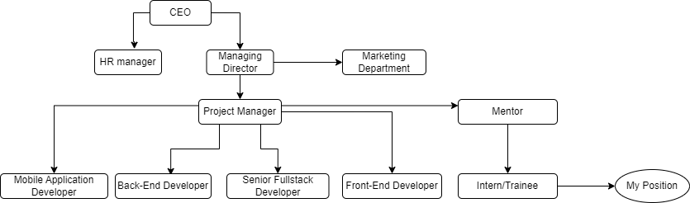

**Figure 1 Organizational Chart**

### 2.3 Working Domains of Organization

Softech Foundation Pvt. Ltd. is a leading IT company in Nepal, dedicated to providing high-quality training, web and desktop application development, GIS solutions, consultancy services, data entry, webpage design, and IT-related jobs. With a focus on strategic business planning and technology utilization, the company aims to meet unique business challenges and empower clients for success. Serving both government and non-government organizations, Softech Foundation has earned a strong reputation for delivering world-class services. As a Microsoft Certified Gold Partner, it showcases expertise in security solutions, information worker solutions, desktop platforms, system management, and business intelligence. Committed to customer satisfaction and professionalism, Softech Foundation continues to make a significant impact in the IT industry.

### 2.4 Description of Intern Department

The general internship duration in Softech Foundation Pvt. Ltd is of three months. The specific intern roles are aligned with their interests and the organization's needs. Each intern is assigned a supervisor based on their respective field of work. Under the guidance of senior developers, the interns carry out their daily tasks and must meet performance expectations set by their supervisors. Interns need to report their progress and share details of their work done within the company to their supervisor.

### 2.5 Literature Review

#### 2.5.1 Background and Contextual Research

An educational consultancy firm benefits significantly from having its own website. The website serves as a powerful online platform to showcase the consultancy's services, expertise, and achievements. Prospective clients can easily access information about the consultancy's offerings, such as college and university admissions guidance, study abroad programs, career counseling, and test preparation services. The website also provides valuable resources, including articles, blogs, and FAQs, to address common queries and concerns of students and parents. Through the website, the consultancy can efficiently communicate with clients, enabling them to make inquiries, book appointments, and receive personalized assistance. Additionally, the website enhances the consultancy's credibility and professional image, helping to attract a wider audience and establish a strong online presence in the competitive educational consulting market.

The benefits of educational web development aren’t just limited to students but extend to benefit teachers as well. Teachers too, use educational websites on a large scale. The interactive training and learning techniques employed in these websites offer a whole new perspective to teachers, who can further incorporate these techniques in conventional classrooms, and thus help students with a better understanding of the concepts. (Brainmine, 2019)

It is highly recommended to visit the website and social media pages, such as Facebook or Instagram, of educational consultancies before making a physical visit. These platforms often provide abundant information about the consultancy, including their credentials, expertise, team, and background. By reviewing these details beforehand, we can gain valuable insights and make informed decisions before scheduling an in-person visit. (Admin, 2020)

Here are some of the best educational consultancy websites in Nepal as of July 11, 2023. International Career Counselling (ICCC) specializes in assisting students for Canada with branches in Pokhara, Kathmandu, and Canada. Popular Consultancy Nepal offers expert career counseling and settlement services for students interested in Canada. NIEC (National Institute of Education and Consultancy) provides admission services for universities in Australia, the USA, the UK, New Zealand, Ireland, and Canada, along with language classes and immigration services. Himalayan White House Education Consultancy assists with visa services for countries like the UK, USA, Canada, Australia, New Zealand, and more. The Next Education Consultancy is a comprehensive service provider with branches across Nepal and a support office in Sydney, primarily focusing on opportunities in Australia. Dolphin Education Consultancy Centre Pvt. Ltd. (DECC) assists students for the UK, USA, Canada, Australia, and New Zealand, and AECC Global offers global assistance with offices worldwide, making foreign education accessible to all students. (wapnepal, 2023)

#### 2.5.2 Related Works

##### **1. Moonlight Education Consultancy**

Moonlight Education Consultancy is a rising educational consultancy that offers a wide range of services, including assistance from registered migration agents. They provide excellent opportunities for studying abroad in some of the best educational hubs worldwide, such as the UK, USA, India, Australia, Japan, Canada, France, and New Zealand. Moonlight Education Consultancy recognizes the significance of education in shaping a student's career and is dedicated to helping students make informed decisions. They prioritize providing students with comprehensive information on available options, empowering them to make valuable choices for their future.

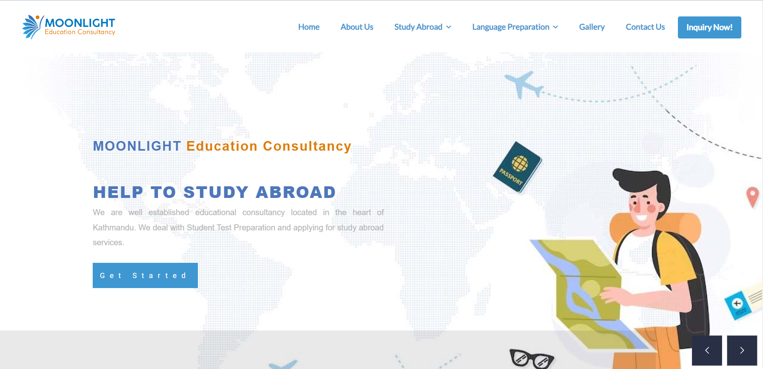

**Figure 2 Related Work**

# CHAPTER 3

## INTERNSHIP ACTIVITIES

### 3.1 Roles and Responsibility

During my internship at Softech Foundation Pvt. Ltd., my role as a web developer (FrontEnd Developer) Intern involved handling various aspects of web application development. I gained hands-on experience in HTML, CSS, JS and Bootstrap, and other relevant technologies essential for creating web applications.

**Roles**

* Frontend Development
* User Interaction Features

**Responsibility**

* HTML/CSS Development: Writing clean and semantic HTML and CSS code to structure and style the website's elements. Ensure cross-browser compatibility and responsiveness to make the site accessible on various devices and screen sizes.
* JavaScript Implementation: Enhancing the website's interactivity by incorporating JavaScript functionalities. This include creating smooth animations, dropdown menus, and interactive elements to engage users effectively.
* Front-End Frameworks: Utilizing front-end frameworks like Bootstrap or Foundation to streamline the development process.
* Mobile Optimization: Prioritizing mobile-first design principles to ensure that the website looks and functions well on smartphones and tablets. Implementing responsive design techniques to adapt content to different screen sizes.
* Inquiry Forms: Designing and implementing user-friendly inquiry forms where visitors can request information about educational programs, application processes, or any other relevant inquiries.
* Contact Forms: Creating contact forms that allow users to get in touch with the consultancy for general inquiries or specific questions.

### 3.2 Weekly log

In the first few weeks, Interns will be guided through general concepts of web app development. For the remaining time, the intern shall be directed and involved in a specific real life project and trained accordingly.

#### Table 1 Timeline of Internship in Weekly Format

|  |  |  |
| --- | --- | --- |
| Week | Date | Description |
| 1st Week | 9th May – 13th May | Became familiar with the frontend codebase, reviewed existing frontend projects, and set up the development environments. |
| 2nd Week | 14th May – 20th May | Revision of HTML elements and structure, CSS properties, building a parallax website using position and display. |
| 3rd Week | 21st May – 27th May | Became familiar with flaticon and font awesome, building a simple restaurant website using grid, display, and position. |
| 4th Week | 28th May – 3rd June | Revision on Bootstrap and its components, understanding responsive website and user experience and interface. |
| 5th Week | 4th June – 10th June | New project assigned and designed home page using HTML elements and structure, CSS properties, aos animation and bootstrap. Navbar, dropdown, hamburger menu, header, and jumbotron was integrated and made responsive. |
| 6th Week | 11th June – 17th June | Designed responsive about, services, partners, countries section in home incorporating bootstrap grid, container, carousel and css properties like position, header, paragraph, js, using flaticon as well as aos animation. |
| 7th Week | 18th June – 24th June | Designed responsive testimonial and footer section in home incorporating bootstrap grid, and css properties like position, header, paragraph, using flaticon as well as aos animation. |
| 8th Week | 25th June – 1st July | Designed responsive about us page which consist Bootstrap grid , accordion, flaticon, and css properties. |
| 9th Week | 2nd July – 8th July | Designed responsive study abroad pages, Australia page was designed incorporating grid, css properties, flaticon, accordion and lighbox for gallery. Consulting form was design for this page. |
| 10th Week | 9th July – 15th July | Designed responsive study abroad pages, Canada, Denmark, UK and USA page was designed. |
| 11th Week | 15th July – 22nd July | Designed responsive language classes pages, IELTS page was designed incorporating grid, image, button, css properties, flaticon, and accordion. |
| 12th Week | 23rd July – 29th July | Designed responsive language classes pages, PTE, TOEFL, GRE, DOULINGO, GMAT and SAT page is designed. |
| 13th Week | 30th July – 5th August | Gallery page was designed and made responsive using a library lightbox, js, and css properties, Contact page is designed using bootstrap grid, css properties. Contact form is created and a map is placed. |
| 14th Week | 6th August – 12th August | Login, signup and inquiry page was designed and made responsive using form, grid and css properties. |
| 15th Week | 13th August – 16th August | Website looks and functions on smartphones and tablets were tested and improved. Responsive design on different screen sizes was tested and corrected. |

### 3.3 Description of the project involved during internship

The internship period at Softech Foundation Pvt. Ltd. is designed in three-month intervals. I started my internship program in FrontEnd Development on 9th May, 2023 and ended on 16th August, 2023. During the internship project I designed web pages for an educational consultancy named Trailmaker that provides all the information related to study abroad, test preparation classes and visa process. The project used HTML, CSS, JS, Lightbox2, Font Awesome, Flaticon and Owl Carousel as a frontend for the specific project. Google Chat was used for communication for review, tips and some sort of help. Domain name and a hosting plan was and registered with cPanel access. All the project files (HTML, CSS, JavaScript, images, etc.) were uploaded to the "public_html". VSCode was used for coding and programming the project web application and Google Chrome and Microsoft Edge was used for generating the frontend outcome of the programmed code.

#### 3.3.4 Module of the project

The project typically consists of various modules to provide comprehensive information and services to its users. Here are some common modules that can be included in Trail Maker Educational Consultancy website:

1. **Home**: A landing page that introduces the consultancy and highlights its core services and unique selling points.
2. **About Us**: A section that provides information about the consultancy's background, mission, values, team members and message from MD.
3. **Study Abroad**: A dedicated section providing details about study abroad destinations, popular universities, admission requirements, and scholarship opportunities.
4. **Language classes**: A section that provides information about the test preparation classes and their test format.
5. **Gallery**: A section that displays images of events and activities in the consultancy
6. **Contact Us:** A page with contact information, including phone numbers, email addresses, and a contact form for users to get in touch with the consultancy.
7. **Inquiry Now**: A section that allows visitors to fill the form for quieries.

### 3.4 Tasks/Activities Performed

The name of the project is ‘Trail Maker Educational Consultancy’ also known as ‘Trail Maker’, a project initiated by SoftechFoundation Pvt. Ltd. is a Educational website, that provides all the information related to study abroad, test preparation classes and visa process.

The task/activities performed varies based on the web pages that is designed. When designing the pages various metadata and links to external resources for a webpage were implemented. The technical details of the <head> section consists of the HTML structure of this webpage is meticulously crafted to ensure modern standards and optimal user experience. It begins with a declaration specifying HTML5, the latest standard, followed by setting the document's language to English for accessibility and SEO purposes. Crucially, the character encoding is established as UTF-8 for consistent text rendering across platforms.

The viewport is configured with a meta tag, enabling responsive design by adapting to different device screen widths and zoom levels. Various <link> elements are employed to reference external CSS files, including Bootstrap, icon fonts, Swiper for sliders, custom styles, and external libraries like font-awesome, aos animation. These stylesheets contribute to the webpage's aesthetic and functional aspects.

Additionally, a descriptive <title> is provided for the browser's title bar, enhancing the webpage's identification. Lastly, a custom SVG favicon adds a touch of brand identity to the site, ensuring it stands out visually. Together, these elements form a well-structured foundation for an engaging and user-friendly web experience.

The preloader, top header, navbar, mobile device navbar, footer and inner hero are common throughout the pages. The technical details for these in the <body> section of the HTML document as follows:

1. Preloader: The preloader on this webpage is a visually engaging loading indicator implemented using HTML and CSS. Positioned at the forefront with a high z-index, the "preloader-area" <div> gracefully covers the entire viewport during page loading. Its loader animation, centered both vertically and horizontally, provides a sleek loading experience. What sets it apart is the incorporation of a custom logo ("logo.png") instead of the typical animation, adding a unique touch to the loading process. This preloader's responsive design ensures seamless adaptation to various screen sizes and orientations, enhancing user interaction.
2. Top Header: This CSS code snippet focuses on enhancing the visual appeal and responsiveness of the webpage's header section. It achieves this by carefully styling various elements. The background color of the top header is set to an appealing blue and white combination. Contact information elements benefit from font size and color adjustments, ensuring they are easily readable. Social media icons are given a cohesive look with specified colors and hover effects. Moreover, the code demonstrates responsiveness, adapting the header's layout for screens to provide an optimal user experience.
3. Navbar: A responsive website navigation bar was created. A `<nav>` element with the class "navbar navbar-expand-lg" was employed to conform to modern HTML5 standards and adapt to larger screens. The logo, contained within an `<img>` element under the "navbar-brand" class, links to the homepage and has a set height of 80 pixels. For mobile responsiveness, a "navbar-toggler" button, activated via Bootstrap attributes, reveals the navigation menu with three horizontal bars denoting a burger menu icon. The menu, displayed as an unordered list with "navbar-nav mx-auto," is horizontally centered, while dropdown menus for "About Us," "Study Abroad," and "Language Classes" provide a user-friendly hierarchy. Additional direct links to "Gallery" and "Contact Us" are present. Finally, the navigation bar offers user options with "Log In" and an "Inquiry Now" button, enhancing user interaction.
4. Mobile device navbar: The mobile navigation menu employs Bootstrap's offcanvas component, enclosed in a `<div>` with the class "responsive-navbar offcanvas offcanvas-end." Within this menu, the site's logo is linked via an `<img>` element. A "Close" button, featuring a close icon represented by an `<i>` element, allows users to dismiss the menu. The menu items are structured as an accordion, implemented using `<a>` and `<button>` elements with relevant classes. These items expand to reveal sub-menu options upon interaction, thanks to Bootstrap's data attributes. Sub-menus exist for "About Us," "Study Abroad," and "Language Classes." In contrast, "Gallery" and "Contact Us" are direct links. Lastly, user options like "Log In" and "Inquiry Now" are provided at the menu's bottom. This approach ensures user-friendly navigation on mobile devices.
5. Footer: The website's footer consists of two main sections, namely the "footer-warp" and the "copy-right-warp." The "footer-warp" is a container that utilizes HTML and CSS to structure its content. It includes a logo, textual description, various links organized using unordered lists (ul) and list items (li), contact details like email, address, operating hours, and a phone number. The "copy-right-warp" contains copyright information displayed in a container, specifying the year and copyright holder. Additionally, there's an attribution link to the website developer. HTML input fields and buttons are employed for the newsletter subscription form. Aesthetically, images are used for elements like footer shapes and contact icons. External links to stylesheets and JavaScript libraries enhance styling and functionality.
6. Inner hero: It features a background color (#F4F9FF), padding for spacing, and an overlaid image (inner-hero-shape1) to enhance visual appeal. The inner-hero-content div contains the page title. The page title is styled with a larger font size (40px) and the Roboto font-family. The list items (li) are styled with custom positioning, colors, and a decorative pseudo-element (::before).

For the web pages. The task/activities performed are as follows:

Home: The landing page or the home page is designed and implemented, incorporating engaging visual elements and responsive layouts to introduce the consultancy, showcase its core services, and highlight its unique selling points.

The technical details of the <body> section of the HTML document as follows:

1. Hero: The hero section is constructed with a `<div>` element, utilizing Bootstrap's grid system for a two-column layout. The left column contains key textual elements, including a stylized main heading, company name, and a brief description. Two call-to-action buttons are provided. The right column, currently commented out, is reserved for a potential hero image.
2. About: The "About Warp" section employs HTML and CSS for structure and styling. It uses Bootstrap grid classes for responsive layout management, ensuring content alignment across various screen sizes. Images are displayed using `<img>` elements sourced from the "assets/images/abouts" directory, organized in rows and columns. The textual content is properly formatted and styled with CSS, while Font Awesome icons (e.g., "fas fa-check" and "fas fa-bullseye") enhance visual elements. An accordion feature, facilitated by Bootstrap's "accordion" and "collapse" components, enables expandable sections. CSS is used for content alignment.
3. Services: The "Our Services" section is crafted using HTML and CSS, with some animations added using AOS (Animate on Scroll) library through data attributes like "data-aos" and "data-aos-duration." It utilizes Bootstrap's grid system for responsive design, ensuring proper alignment of content on different screen sizes. Images are displayed with `<img>` elements, sourced from the "assets/images/benefits" directory. The textual content is organized and styled using CSS. Icons are integrated as `<img>` elements for visual representation, with CSS for positioning. The section presents a list of services with accompanying descriptions, structured as an unordered list `<ul>`. Each service item is represented as a list item `<li>` and includes an icon image and descriptive content. Overall, this section effectively combines HTML, CSS, and animation to showcase the range of services offered by the organization in a visually appealing manner.
4. Association: The "Our Association with These Worldwide Universities" section is implemented using HTML, CSS, and JavaScript libraries for carousel functionality. It begins with a container element containing a heading that's styled with CSS for presentation. Within this container, a carousel of client logos is created using the Owl Carousel library. Each university logo is wrapped in a `<div>` element with the class "item box," and the images are sourced from the "assets/images/partners" directory. The JavaScript section code snippet includes references to external libraries: Bootstrap, jQuery, and Owl Carousel. It initializes the Owl Carousel for the "clients-carousel" class, configuring settings such as autoplay, loop, margin, and responsive behavior for different screen sizes.
5. Javascript files: The provided code snippet includes links to various JavaScript (JS) files used to enhance the website's functionality and interactivity. These include Bootstrap for responsive design, scrollCue for scroll animations, and custom.js for site-specific functions. Additionally, Font Awesome is used for scalable vector icons, and AOS.js adds smooth scroll animations. These JS files collectively contribute to the website's user experience and interactivity.

About Us: The About Us consists of two pages. They are Company profile and Message from MD. About Us presents detailed information about the consultancy's background, mission, values, team members, and a personalized message from the Managing Director to establish a strong connection with visitors.

Company Profile page: This page presents the background information about the consultancy along with its mission and vision. The technical details of the <body> section of the HTML document as follows:

1. About company: In this section the CSS styles encompass various aspects, including headings, navigation pills, mission content layout, and image positioning. These styles ensure proper spacing, font consistency, background colors, and hover effects for navigation links, resulting in an engaging and responsive design. Additionally, they structure the mission content within tabs, adjust margins, and emphasize font styles, enhancing readability and aesthetics.

Message from MD page: This page presents a personalized message from the Managing Director to establish a strong connection with visitors. The technical details of the <body> section of the HTML document as follows:

1. Message from MD: It includes styling for headings, navigation menus, mission content, and images. Notably, it styles navigation links adding hover and active effects. The `.image` class defines styles for images within the section. Additionally, the ‘.social’ class contribute to networking and connection to the MD.

Study Abroad: This page offers comprehensive details about study abroad destinations, popular universities, admission requirements, and available scholarship opportunities to assist potential international students based on the countries. The technical details are as follows:

1. Country Details Section Structure: The entire section is enclosed in a div element with the class country-details. This class controls the padding of the section.
2. Content Layout: Within this section, there is a two-column layout. The left column (col-lg-8) contains the primary content, including textual information about studying, working, and living in abroad, as well as details about various visa types. The right column (col-lg-4) contains links to other related pages and a form for consulting services.
3. Styling Elements: The CSS code specifies various styles for different elements within the content:
4. Headings (h3) are styled with larger font sizes for emphasis.
5. Lists are styled to remove default bullet points (list-style: none) and add custom icons and colors.
6. Links within lists change their appearance when hovered, improving user experience.
7. Consulting Form: The right column contains a form with input fields for name, email, phone, and a dropdown for selecting a country. The form is styled to have a consistent and user-friendly appearance.
8. Accordion: The section includes an accordion widget with frequently asked questions (FAQs) about studying in Australia. Users can expand and collapse each question to view the answers. The accordion structure is created using Bootstrap classes and JavaScript.
9. Country Links: Links to pages related to studying in different countries are presented as buttons. Hover effects, such as changing the background color and displaying icons, make these links more engaging.
10. Image Styling: Images are styled with margins to control their placement within the content.

Language Classes: This page offers comprehensive information about the available test preparation classes and their test formats to aid students in their language proficiency goals. The technical details of Language Classes are as follows:

1. HTML Structure: The HTML code represents a webpage layout for showcasing information related to DUOLINGO test preparation. It is organized into sections, including "Language Details" which is divided into columns to structure the content effectively. The left column (col-lg-8) contains the primary content, including textual information about studying, working, and living in abroad, as well as details about various visa types. The right column (col-lg-4) contains links to other related pages and a form for consulting services.
2. CSS Styling: The CSS code defines the visual styling for various elements on the webpage. It employs classes and selectors to format text, margins, padding, and visual effects like box shadows and transitions.
3. Benefit Details Styling: The "benefit-details" section provides information about the benefits of DUOLINGO classes. It uses ordered and unordered lists to organize content and includes custom styling for list items with icons.
4. Question Styling: The "question" section is formatted for an accordion-style widget, providing expandable sections for different types of test formats. This enhances user interaction and content organization.
5. Form Styling: The CSS styles form elements like input fields, text areas, and dropdowns for a clean and user-friendly appearance. Placeholder text changes color on focus for better user experience.

Gallery: This page displays images of events and activities organized by the consultancy, providing visitors with a glimpse of the enriching experiences they could expect. The technical details are as follows:

1. HTML Structure: The HTML code defines a section for a photo album. It starts with a heading indicating "TrailMaker's Album" and a brief description of the content. The main section contains two parts: a button group for filtering images and a gallery displaying images categorized as events, classroom, and activities.
2. Button Group: Within the "button-group" div, there are buttons that allow users to filter images by category. Initially, the "All" button is marked as active. Users can click on these buttons to filter the images displayed in the gallery.
3. Image Gallery: The "gallery" div contains multiple "item" divs, each representing an image. Images are categorized using classes like "events," "classroom," or "activities." The images are wrapped in anchor tags with links to larger versions for a lightbox effect, allowing users to view images in detail.
4. JavaScript Functionality: The JavaScript code at the bottom of the HTML is responsible for filtering the images when a button is clicked. It uses the Isotope library to achieve this functionality. Initially, the Isotope library is initialized on the ".gallery" container with a "fitRows" layout mode, which arranges images in a grid.

The click event handler for the buttons removes the "active" class from all buttons and adds it to the clicked button. It then retrieves the "data-filter" attribute value from the clicked button, representing the desired category. Finally, it uses Isotope to filter and display only the images matching the selected category.

Contact Us. This page incorporates contact information, phone numbers, email addresses, and a user-friendly contact form to facilitate easy communication between the consultancy and interested users. The technical details of the Contact Us are as follows:

1. Contact Content Section: The heading ("<h4>") inside the ".contact-content" is styled with a font size of 30px and a margin-bottom of 12px. The paragraph ("<p>") below the heading has a margin-bottom of 40px. Lists ("<ul>") inside the contact content are styled to remove default list styles. List items ("<li>") have specific styling: the first list item has a larger font size, bold text, and a distinct color. Links ("<a>") within list items are styled with a gray color.
2. Contact Share Icons: Social sharing icons are styled within the ".contact-share" class. The icons are displayed inline and have padding and a background color. On hover, the icons change their background color to create an interactive effect.
3. Contact Form Section: The ".contact-form" section is styled with padding, a background color (#F7F9FA), and a box shadow. It is slightly pushed up (negative margin and positioning) to create a visual distinction from the contact content section. The form title ("<h4>") has a font weight of 800, a font size of 22px, and a distinct color. It also includes a horizontal line ("<hr>") below it using the "::before" pseudo-element. Form controls (input fields and textarea) have specific styling. They have a white background, padding, and a subtle box shadow on focus. Placeholder text changes color when focused. The submit button ("Send Message") is styled as a default button with a width of 100%.
4. Map Section: The map is wrapped within a ".map-warp" div, and the iframe displaying the map is set to a width of 100% and a height of 800px. A negative margin is applied to the map-warp to ensure it doesn't create additional spacing.

Inquiry Now: This page allows visitors to fill out a user-friendly form for inquiries and queries, streamlining the communication process and enhancing user engagement. The technical details of Inquiry Now are as follows:

1. CSS Styling for the Apply Warp Section: The CSS code is responsible for styling the "Apply Warp" section of the web page, which is used for visitors to apply for a consultation directly.
2. Padding and Background: The ".apply-widget" class adds padding of 100 pixels to the section, creating space around the content. It sets the background color to white (#ffffff) and applies a subtle box shadow to the section to give it a sense of elevation and separation from the background.
3. Section Heading: The heading ("<h4>") within the "apply-widget" is styled with a font size of 25 pixels and a margin-bottom of 30 pixels. This makes the heading visually appealing and provides spacing below it.
4. Form Inputs: Form inputs with the ".form-control" class are styled consistently. They have a height of 55 pixels, left padding of 20 pixels, and a margin-bottom of 20 pixels. The text color is a light gray (#ADADAD), and they have a white background color. A smooth transition effect is applied to these inputs over 0.5 seconds.
5. Input Focus: When an input field is focused, the box shadow is removed, and the border color changes to a light red (#FF3838), providing visual feedback to the user. Placeholder text becomes transparent when an input is focused to make it more readable.
6. Textarea Styling: The textarea within the form is styled to have a height of 155 pixels and a padding-top of 12 pixels, ensuring it has enough height and spacing for text input.
7. Submit Button: The submit button is given the ".default-btn" class and styled without borders. A green background color (#00803E) is applied to the button. When hovered over, the button has a color change effect to make it visually interactive.

In terms of frontend technologies, I utilized HTML, CSS, JS, Sass, Lightbox2, Swiper-Bundle, Font Awesome, Flaticon, and Owl Carousel to create an intuitive and visually appealing user interface for the website.

# 

# CHAPTER 4

## CONCLUSION AND LEARNING OUTCOMES

### 4.1 Conclusion

To successfully achieve the objective of designing, developing, and deploying a user-friendly, responsive website for Trail Maker Educational Consultancy, I employed a structured approach that involved gathering specific requirements, selecting appropriate technologies such as HTML5, Bootstrap 5, JavaScript, Owl Carousel, Lightbox, Flaticon, and AOS animation, and meticulously implementing these technologies to create a visually appealing and functional website. This process encompassed tasks such as planning, HTML5 markup, Bootstrap integration for responsive design, JavaScript for interactivity, Owl Carousel for image carousels, Lightbox for image galleries, Flaticon for icons, and AOS animations for scroll effects. Rigorous testing, deployment, documentation, and potential user training ensured the successful delivery of a dynamic online platform that met Trail Maker's goals and provided an exceptional user experience.

### 4.2 Learning Outcome

The major learning from the internship period may be described as learning new programming concepts, solving and debugging mistakes, becoming familiar with new modules, techniques, remaining on schedule, maintaining social interactions with other employees, and so on.

Some of learning Outcomes of me after completion of this intern session are:

* Improved proficiency in frontend development languages and technologies such as HTML, CSS, JavaScript, and Bootstrap.
* Enhanced ability to create visually appealing and user-friendly interfaces for websites and web applications.
* Practical experience in implementing responsive design techniques and ensuring compatibility across different devices and browsers.
* Understanding of industry best practices in web design, usability, and user experience.
* Familiarity with version control systems and collaborative development workflows.
* Ability to work effectively in a team, collaborate with designers and backend developers, and communicate ideas and solutions.
* Development of problem-solving skills through troubleshooting and debugging frontend issues.
* Awareness of web accessibility standards and considerations to create inclusive and user-friendly experiences.
* Creation of a portfolio showcasing the internship projects and demonstrating skills in frontend development.
* Increased confidence and readiness to pursue a career in frontend development or related roles.

# References

**Admin. 2020.** educational-consultancy-in-kathmandu-nepal. *edwisefoundation.* [Online] 06 12, 2020. https://edwisefoundation.com/education-consultancy-in-kathmandu-nepal/.

**Brainmine. 2019.** Types of Educational Websites and the Benefits of Educational Web Development. *BrainMine.* [Online] 07 26, 2019. https://www.brainminetech.com/blog/types-educational-websites-benefits-educational-web-development/.

**Foundation, Softech. 2023.** company. *Softech Foundation.* [Online] 04 12, 2023. https://softechfoundation.com/company.

**wapnepal. 2023.** best-consultancies-in-nepal. *wapnepal.* [Online] 07 11, 2023. https://wapnepal.com.np/best-consultancies-in-nepal/.

## Appendices

1. Home Page

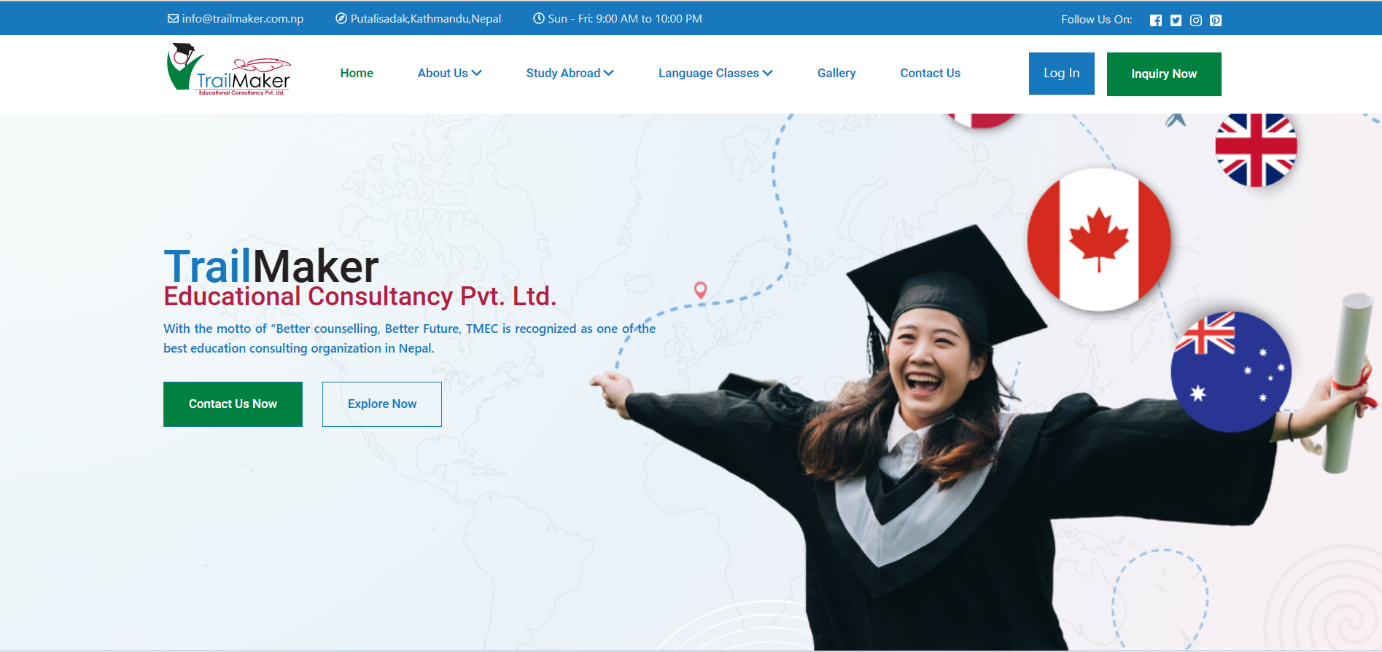

1. Company Profile of About Us page

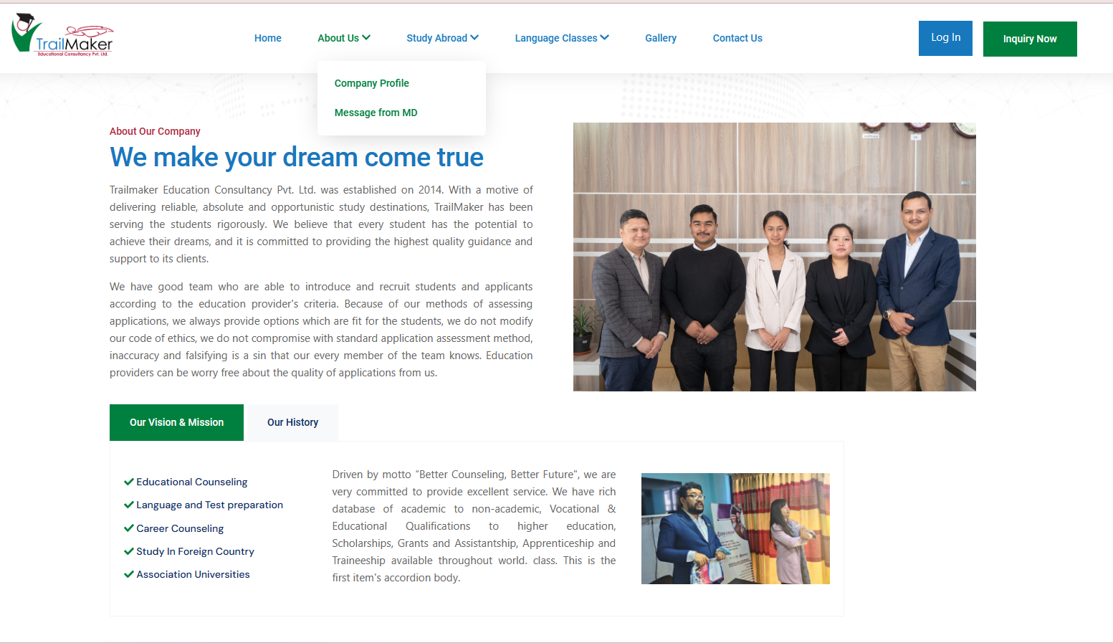

1. Study in Australia page of Study Abroad

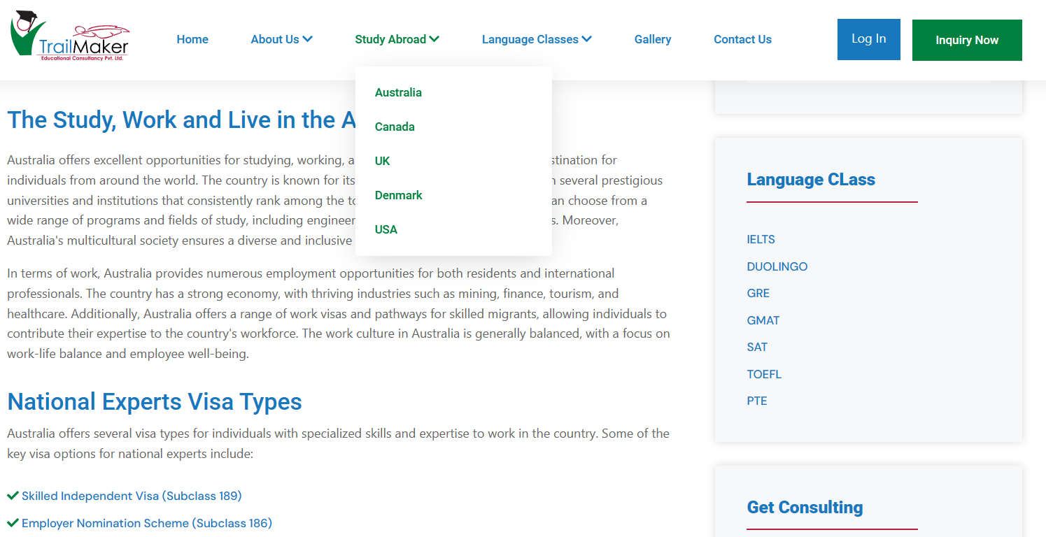

1. IELTS page of Language classes

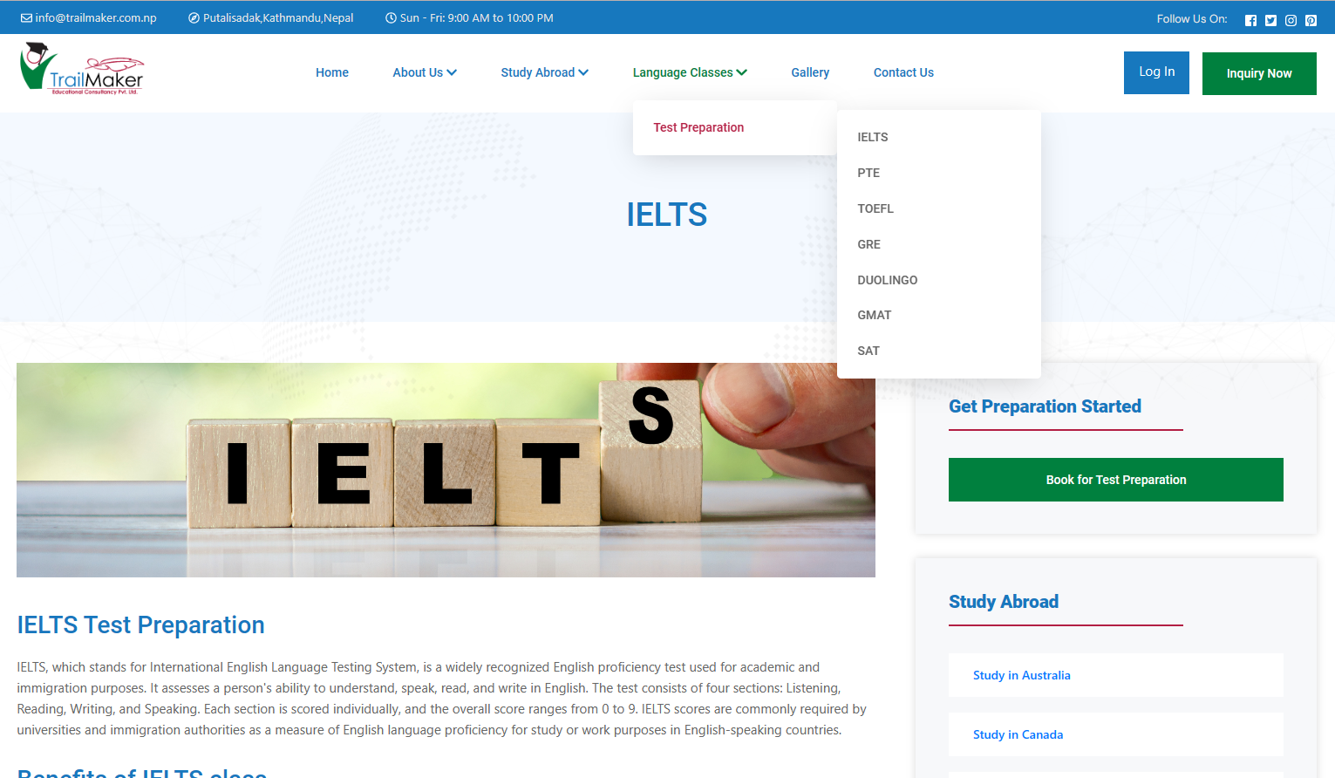

1. Galllery page

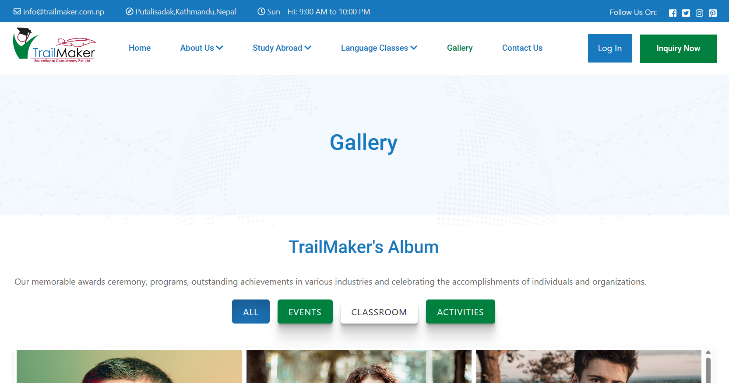

1. Contact Us page

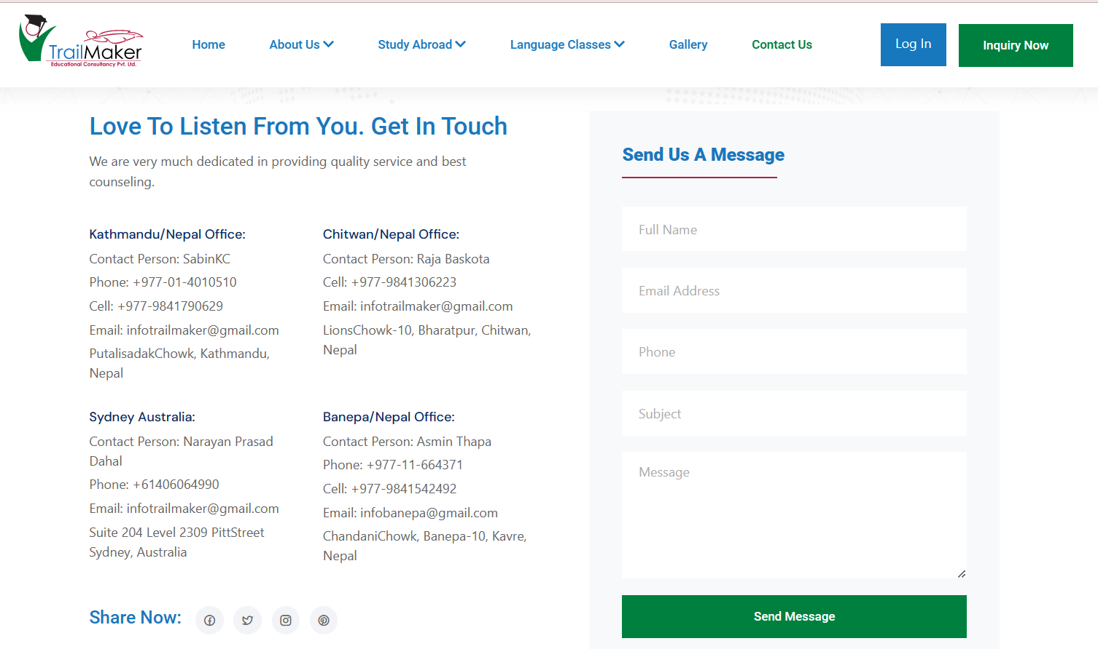

1. Inquiry page

